DRAGON TAILS

DIRECTIONS: Pull the ‘tail”, which is any piece of clothing, that you can put in your pocket or hang from your shorts/plants. If you are able to pull a tail on either side of your opponent, then you win that round.
EQUIPMENT NEEDED  - SOCKS  - OPEN SPACE – BOUNDARIES  YOU CAN USE ANY PIECE OF CLOTHING THAT CAN HANG FROM YOUR SHORTS/PANTS!  IN CLASS – WE USED FLAGS AND SCARVES. | 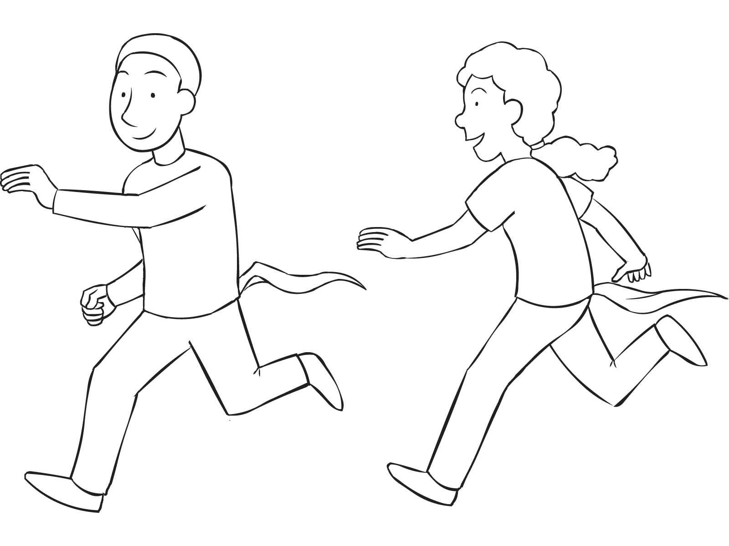  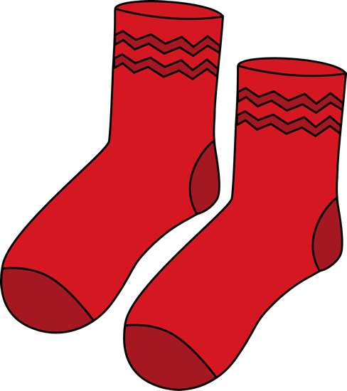
RULES (Play to any score you want)

GOAL: PULL ONE “TAIL” FROM YOUR PARTNER AND DO NOT LET THEM GRAB YOURS.

- FIND A BOUNDARY THAT YOU CANNOT STEP OUT OF
- NO FLAG GUARDING (HOLDING OR BLOCKING)
- NO PUSHING
- BE CAREFUL OF SURROUNDINGS

REMEMBER: YOU CAN PLAY WITH MORE THAN TWO PEOPLE – AS LONG AS THEY CAN FIT IN THE SAFE AREA!

SAFETY FIRST!

