PAPER CORN HOLE

DIRECTIONS: Toss an object to the created paperboard. There are 9 boxes to possibly score on and each box has a certain amount of points. You will still receive a point for your object touching the paper at ANY point – even if it does stay/land on the paper.
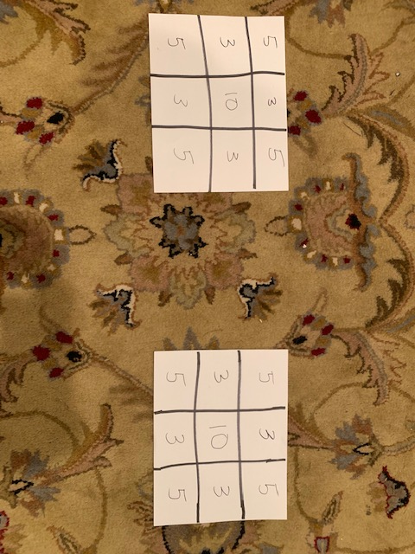  EXAMPLE OF PAPER BOARD | 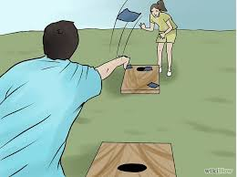  EXAMPLE OF ACTUAL CORN HOLE
EQUIPMENT NEEDED

- PIECES OF PAPER (2 FOR BOARD)
- MARKER TO DRAW BOARD
- 12 PIECES OF OBJECTS (6 PER PLAYERS)
EXAMPLE: I USED PIECES OF PAPER AND HERSHEY’S KISSES

MAKE SURE THERE IS ENOUGH OBJECTS FOR EACH PLAYER TO THROW!

SAFETY NOTE: MAKE SURE YOU HAVE ENOUGH ROOM TO OJECTS WITHOUT HITTING OR BREAKING ANYTHING!
MODIFICATIONS

BEGINNER LEVEL
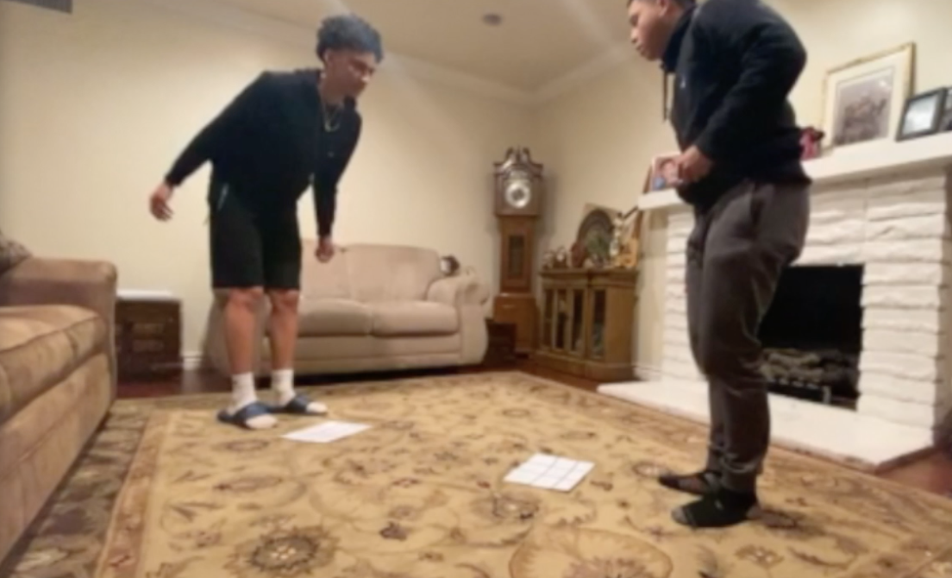

ADVANCED LEVEL

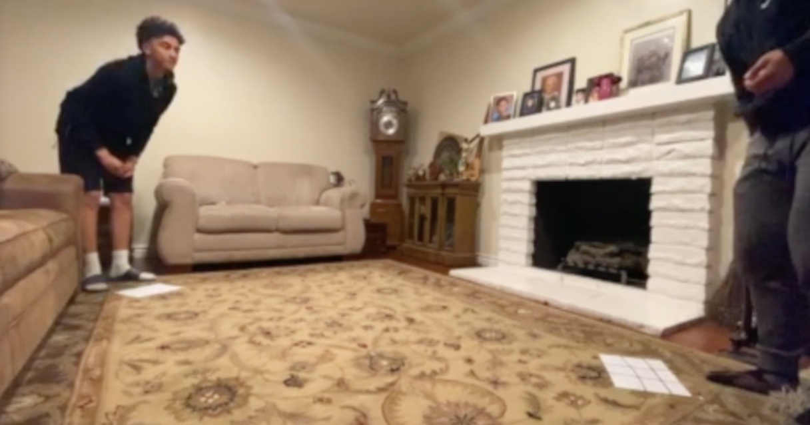

YOU CAN CHANGE THE DISTANCE OF YOUR THROW!

RULES (Play to any score you want)

GOAL: LAND YOUR OBJECT ON THE PAPER BOARD TO RECEIVE POINTS. YOU CAN ONLY SCORE POINTS BY HAVING AN OBJECT TOUCH THE BOARD AT ANY TIME.

- ROCK-PAPER-SCISSORS TO SEE WHO STARTS
- THROW ONE ITEM AT A TIME
- YOU CANNOT STEP OVER YOUR BOARD
- NO DEFENSE
- UNDERHAND THROW ONLY

REMEMBER: SAFETY FIRST!

