TIC-TAC-EXERCISE

DIRECTIONS: Perform each exercise to the best of your ability in order to pick up an object. The goal is to get Tic-Tac-Exercise by getting THREE objects in a row.
EXERCISE IDEAS (10 OF EACH)  - JUMPING JACKS  - PUSH-UPS  - CURL-UPS  - PLANKS  - SQUATS  - RUNNING IN PLACE (10 SECONDS)  - HEEL FLICKS  - ONE FOOT HOP  - DANCING (10 SECONDS)  ANY EXERCISE WE HAVE DONE BEFORE OR YOU WANT TO TRY! | 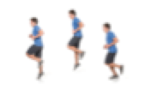  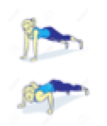  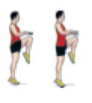
RULES

GOAL: PLACE THREE OBJECTS IN A ROW TO GET TIC-TAC-EXERCISE!

- START BY FACING YOUR PARTNER
- COUNT DOWN FROM 3 SECONDS TO START
- MUST PERFORM EXERCISE CORRECTLY
- CANNOT GRAB OBJECT UNTIL YOU COMPLETED EXERCISE
- CANNOT CHANGE THE POSITION OF THE OBJECT AFTER PLACING IT ON BOARD
- ONLY PICK UP ONE ITEM AT A TIME
- CANNOT DO SAME EXERCISE TWICE IN A ROW

REMEMBER: YOU CAN DO ANY EXERCISE YOU WANT THAT WE LEARNED OR YOU KNOW!

EXAMPLE OF A TIC-TAC-TOE GAME

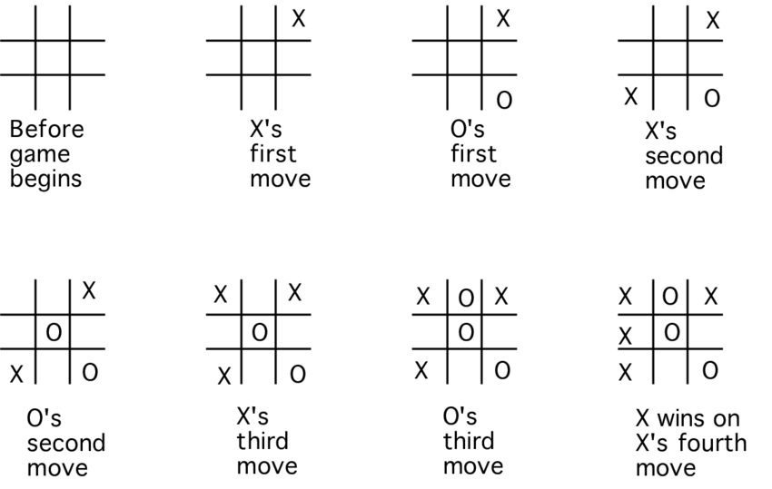

EQUIPMENT NEEDED

- TIC-TAC-TOE BOARD

- 12 PIECES OF OBJECTS (6 PER PLAYER)

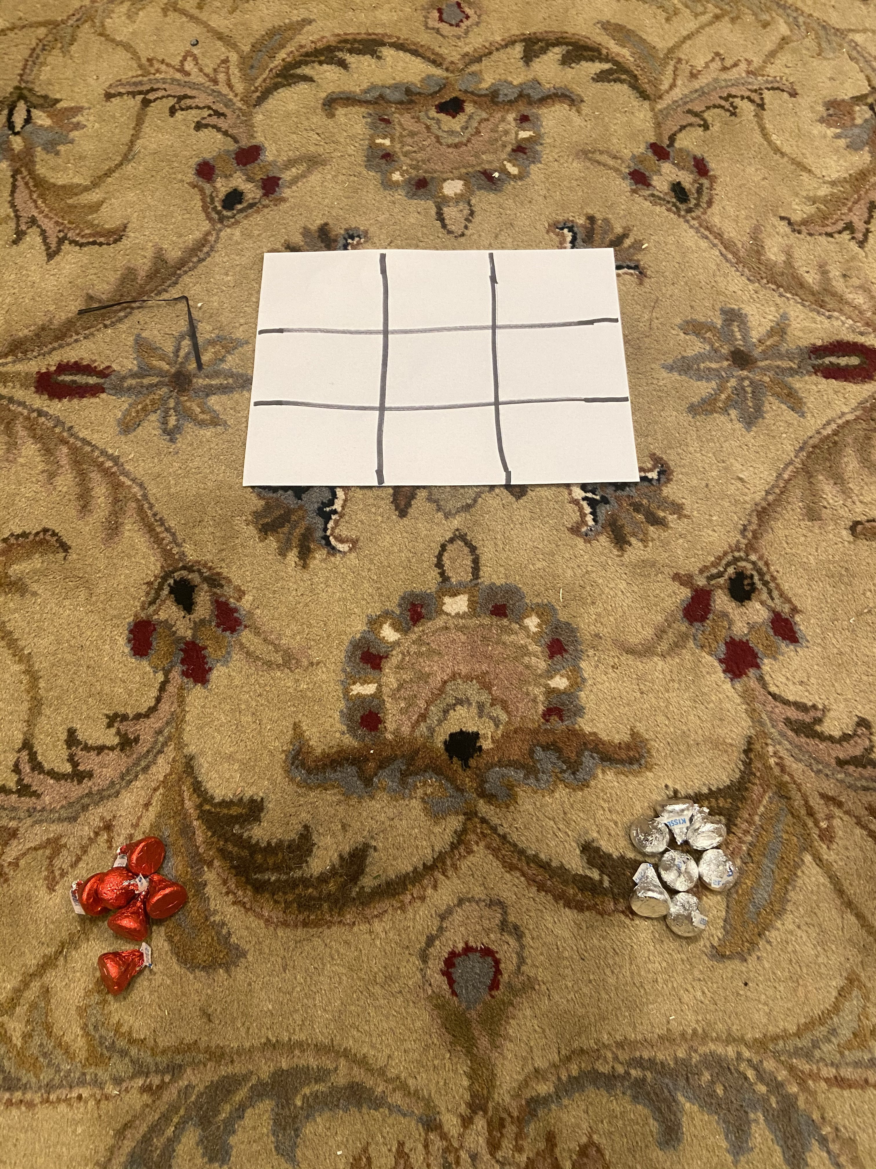

THE EXAMPLE IS SHOWING 12 PIECES OF HERSHEY’S KISSES
(6 RED/6 SILVER)

